Sri Lanka Institute of Information

Technology



Lab Submission

<Lab sheet No 09>

**<IT24101350>**

**<Hansanganee H.R.S.S>**

**Probability and Statistics| IT2120**

B.Sc. (Hons) in Information Technology

******Exercise**

Q1

i)

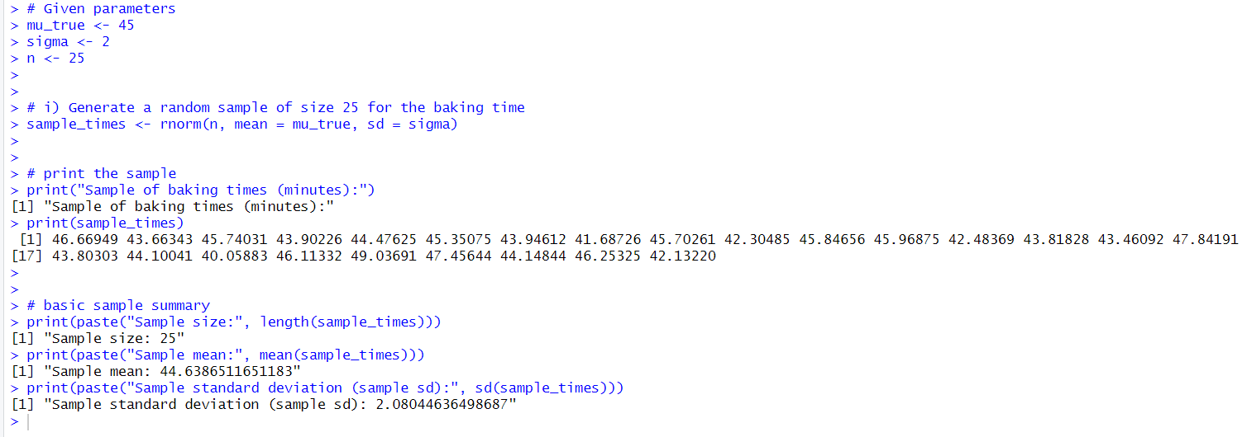

ii)

